The following Rules and Regulations will apply to only to the Winter Classic tournaments. Unless stated otherwise in these rules and regulations, ASA Rules of the Game and CMSA Rules of Play will apply.

CMSA Code of Conduct
The purpose of this policy is to ensure a safe and positive environment within CMSA sanctioned programs, activities, and events by making all individuals aware that there is an expectation of appropriate behaviour consistent with the values of CMSA, at all times.
Team Official Code of Conduct
1. Follow the fair play philosophy that emphasizes the concept of equal participation for equal commitment, respect both the rules and the spirit of the game.
2. Respect the opposition players and coaches and actively encourage their players to do the same.
3. Remember that players need a coach they can respect. Be generous and praise, lead by example and provide all feedback in a constructive, positive manner.
4. Respect the referees and refrain from criticism of their efforts and rulings.
5. Following the CMSA Anti-Discrimination Policy, refrain from any type of discrimination and treat all participants with respect and dignity and appreciate that every individual is unique.
6. Emphasize the importance of active participation and doing ones best over the importance of winning or losing and focus on the quality of the experience, not just the outcome.
7. Promote positive teammate interaction and intervene where negative behaviours are demonstrated.
8. Show zero tolerance for profanity, violent behaviour, bullying and abuse of any kind.
9. Communicate openly and clearly with parents and players to ensure all expectations and feedback are understood.
10. Be receptive to ideas and suggestions from players and parents in developing goals and programs for the team.
11. Protect the safety of all players, referees, spectators, and participants, and create a soccer environment where safe play is valued.
12. Respect fair play and protect the competitive integrity of all levels of youth and minor soccer.
Parent Code of Conduct
1. Model good sporting behavior for your child in all interactions with their teammates, opponents, and referees.
2. Refrain from any criticism of referees; they, like your children, are learning the game and need support and encouragements from all.
3. Provide positive feedback to all players from both teams and offer engagement when they try something creative or demonstrate good skills.
4. Refrain from any type of discrimination and treat all participants with respect and dignity and appreciate that every individual is unique
5. Avoid conflicts with parents from your team and the opposing team.
6. Let the coach do their job; avoid yelling instructions to players from the sidelines, as it can be confusing and frustrating for all.
7. Communicate openly with your coach if you have ideas or concerns; choose a time away from a game situation; treat the coach with respect and work with them for the betterment of the team.
8. Ensure your child abides by the Player Code of Conduct.
Player Code of Conduct
1. Play by the rules of the game.
2. Respect the referees and accept their decisions without criticism.
3. Are fair and positive in your interactions with opponents; without them, there is no game.
4. Encourage and respect all your teammates and help them and the team succeed.
5. Treat your coach with respect and work with the coach for the betterment of the team.
6. Refrain from any type of discrimination and treat all participants with respect and dignity and appreciate that every individual is unique.
7. Accept coaching decisions as part of the game; speak respectfully, openly and honestly in private with your coach should a disagreement arise.
8. Avoid the use of profanity, violent behaviour, bullying and abuse of any kind.
9. Are generous when you win and gracious when you lose.
10. Demonstrate commitment to the team by attending all practices and games (unless necessary to miss one), by working hard and cooperatively at all team events

Team and Player Registration
- Age group requirements:

Player Birth Year(s) | Age Group Categories
2012 or later | U10
2011 or later | U11
2010 or later | U12
2009 or later | U13
2007 or later | U15
2005 or later | U17
2003 or later | U19

1. All players & teams must be currently registered and in good standings with their home organization. Teams must register in the same age group and tier as their current league play division or in a higher age group and tier as their current league play division. Please see the CMSA Call Up Rules for exact rules for your age group. All final decisions regarding team movement and placement for CMSA tournaments will be up to the discretion of the Tournament Coordinator.
2. All teams must produce a roster from their parent organization (for CMSA teams, this is your official team roster. You can get a copy of it from Demosphere, log in like you are scoring a game, click on team roster). Photo ID is not considered proof of registration.
3. PHOTO ID: All teams are required to provide player Photo ID for all individuals (players and team officials) listed on their roster at time of check in. Players will be required to provide Photo ID individually to game officials prior to the start of each game. NO CARD NO PLAY. League U10 teams playing will not be required to obtain cards for tournaments. This will also include electronic playing cards for teams out of CMSA district.
4. TRAVEL PERMITS: Teams travelling from outside of Calgary need to have a copy of their ASA Provincial Roster signed by their parent organization. All out-of-province teams must also produce a travel permit from their provincial or state organization authorizing travel.
5. GUEST PLAYERS: Teams are allowed to pick-up a maximum of 4 (four) guest players who play in the same tier to complete their team roster for the tournament. You can have unlimited guest players from lower tiers. You may not pick-up a higher division player from a lower age group. Players must also be registered in these age groups with their home organization. For example, if a player who could qualify for U15 but is registered to a U17 team with their home organization, they would be ineligible to play with a U15 team in our tournament but eligible to play with a U17 team. Also, a higher tier player cannot play on a lower tier team, even if that player is moving up in age group category (for example, a U13 Tier I player cannot play on a U15 Tier II team). You must prove they are registered for this season as per point 2 (Which means that for Calgary teams, you will need to obtain a copy of your guest player’s team’s official CMSA roster from their coach, manager, or club).
6. Maximum number of players per team is 20 and all can dress for the game.
7. Players can only play with one team during the tournament.
8. Referees will not start any game until both teams have checked in and submitted their rosters to Tournament HQ.
9. You may not add any new player to your team roster after the commencement of your first game unless due to injury. The new player will substitute the injured player on the team roster. The injured player will be removed from the roster and is ineligible to play for the rest of the tournament. No player may be added after the completion of your 3rd game.

Format

7v7 (U10 -U19, All Tiers)
The minimum & maximum number of players allowed on the field at any one time. These numbers include the goalkeeper:
Minimum Number of Players | Maximum Number of Players
5 Players | 7 Players

Substitutions
There are no restrictions as the number of substitutions made during the game. A whole team can be substituted at one time. Substitutions will be made at half when the referee allows it.

Duration of Games
For all age-groups, all games will be 2 – 25-minute halves, half time will be two (2) minutes.

Ball Size
- U10 - U12 AGE GROUPS – size #4
- U13 & OLDER AGE GROUPS – size #5
The game balls will be supplied by CMSA.

Game Sheets
Game sheets will be printed by CMSA and will be given directly to the referees prior to each game.

Uniform and Equipment

Teams must wear numbered jerseys. If colors clash, the home team changes to an alternative color. The referee alone decides if the colors clash. Shin guards MUST be worn – players will not be permitted to play without shin guards. Players must have proper footwear (running shoes or recognized soccer shoes). The wearing of rigid casts or splints will not be allowed. A player shall not wear anything that is dangerous to another player with the referee having the final decision on this matter. Please refer to Canada Soccer [Law 4] regarding other items that can and cannot be worn. Absolutely no jewellery of any kind (this includes all earrings and nose piercings), will be allowed to be worn, except for a medical alert tag. Medic alert tags must be taped in a fashion that is still visible and safe to the wearer and all other players. Using tape to cover any other jewelry is not accepted. If it can be seen, it must be removed.

Discipline

The Tournament Chairperson will rule over all discipline for the tournament. The following carries an automatic one (1) game minimum suspension:

Automatic Red Card.

Two (2) yellow cards in one game (Red Card).

Three (3) yellow cards accumulated throughout the tournament.

Additional penalties are subject to the tournament chairperson’s ruling.

Protests

No protests will be allowed concerning the facts of play, the final decision rests with the referee. Any other type of protest must be received by the tournament HQ or the field marshal at the field location within one hour of the completion of the game in concern. Protests will only be reviewed provided that they are made in writing with cash or money order (made payable to ‘CMSA’) in the amount of $150.

Game Results and Standings

1. All group round-robin games will finish at the end of regulation time.

2. Points will be awarded as follows: 3 points for a win, 1 point for a tie, and 0 points for a loss.

3. Team standings, following completion of the qualifying play, shall be decided on points awarded. In the event that 2 or more teams are equal on points, then the tie breaking rules (outlined below) shall be used to determine the final round-robin standings.

4. For all games that must produce a winner (e.g. medal games), penalty kicks shall be used to determine the winner, if the game is tied at the end of regulation time. (i.e. there is no extra-time)

5. Any goals scored by a winning team that exceed a difference of 5 goals between the two teams in a game shall be ignored when the final score is recorded (the mercy rule).

Tie Breaking Rules
The following tie breaking rules will be used to determine the final team standings where two or more teams are tied on points.
A. PREVIOUS MATCH RESULTS – results against each other – Head-to-Head, if tied move to (B). Where three or more teams are tied on points move directly to (B).
B. GOAL DIFFERENCE – for any teams still tied, by deducting goals against from goals for, the highest goal difference shall be used to determine the final standings.
C. FEWEST GOALS CONCEDED – for any teams still tied, the fewest goals conceded, shall be used to determine the final standings.
D. For any teams still tied, penalty kicks shall be taken to determine which team advances to the next stage of the competition.
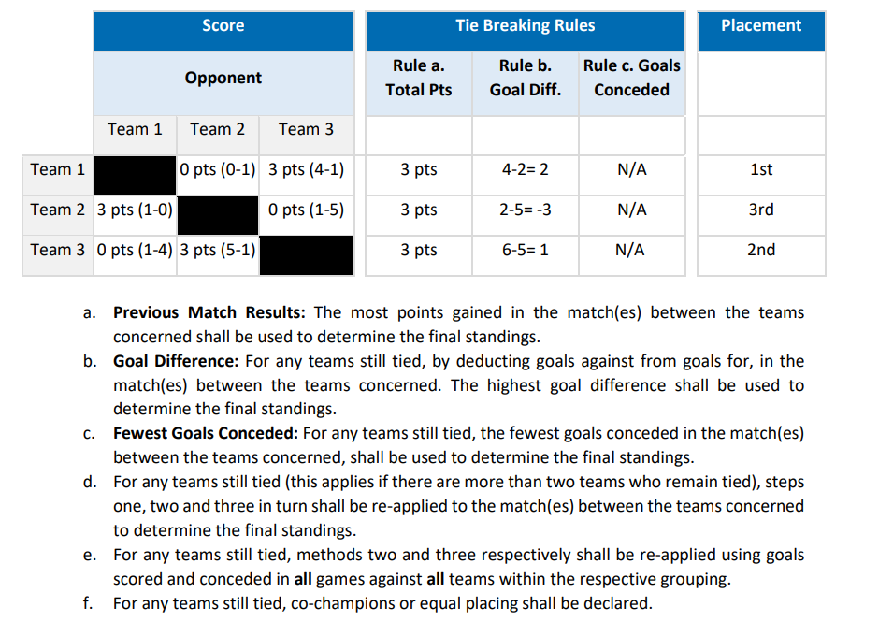

Fair Play and Sportsmanship

The purpose of the tournament is to provide players with a positive and enjoyable experience. Players, coaches, and parents are asked to remember that the game of soccer is to make players better people as well as good soccer players. This may be done by respecting the game officials and applauding the skillful play of the players of both teams. If there is an issue with a parent or coach, they will be asked to leave the building immediately. Failure to do so may result in the game being abandoned and team expelled from the tournament.

Dropouts
All teams are expected to attend and complete their games with a minimum of 5 players. Any team failing to do so will be assessed an administration fee of up to $575 per game that the team does not attend.

Tournament Refund Policy

Cancellations made PRIOR to the tournament registration deadline will receive 100% of the entry fees back. Cancellations received AFTER the tournament registration deadline will be refunded their fees, minus a $100 administrative fee, IF a team is found to replace the canceling team. If a team is NOT found to replace the canceling team, 100% of the funds will be kept by CMSA and no refund will be given. Additional fines, of up to $2500, may be applied to any team whose cancellation past the registration deadline causes a tournament grouping to be cancelled.

All decisions with regards to the administrative fees will be the responsibility of the Tournament & Events Coordinator in conjunction with the Tournaments Committee and notice of all administrative fees will be sent out to the Club that the team was representing.

